**Issues in validation of pre-sliding friction models for ultra-high precision positioning**

Ervin Kamenar a, Saša Zelenika a, [[1]](#footnote-1)

a University of Rijeka – Faculty of Engineering & Centre for Micro- and Nanosciences and Technologies, Rijeka, Croatia

# Abstract

Friction is one of the main disturbances in nanometric positioning. Recently it was also shown that ultra-high precision positioning typically happens in the pre-sliding motion regime where friction is characterized by an elasto-plastic nonlinear hysteretic behavior with a marked stochastic variability. With the aim of providing the tools for the development of robust control typologies for ultra-high precision mechatronics devices, different pre-sliding friction models are thus considered in this work. The most relevant ones are hence experimentally validated, as well as compared in terms of the complexity of identifying their characteristic parameters and of simulating the factual dynamic response. It is hence shown that the Generalized Maxwell-slip model (GMS) can account for all the important pre-sliding frictional effects in nanometric positioning applications. A thorough sensitivity analysis of the parameters of the GMS model is therefore performed allowing to establish that three Maxwell-slip blocks are the minimum needed to approximate the behavior of the real precision positioning systems, six blocks allow representing excellently the real behavior, while the slow dynamics, which induces a difficult real-time implementation of the model, with a very limited gain in terms of model accuracy, does not justify the usage of a larger number of elements.

**Keywords:** pre-sliding friction, identification of parameters, modelling, validation, precision engineering

# Introduction

Ultra-high precision positioning is considered a critical feature in developing mechatronics devices for precision engineering applications as well as, increasingly, in the micro- and nanotechnologies. Precision positioning is, in fact, nowadays broadly used in scientific instrumentation, micro-electro-mechanical systems (MEMS) as well as the handling and assembly of MEMS, precision machine tools, ICT, optical devices etc.1-3

Sliding and rolling components, typically used in ultra-high precision mechatronics devices – especially when the achievable travel ranges and load capacities of compliant mechanisms are exceeded,4 are characterized, however, by nonlinear frictional disturbances that are inherently time-, position- and temperature-dependent with a marked stochastic variability. Friction in these devices induces unwanted effects such as tracking and steady-state errors, limit cycles, stick-slip jitters or large settling times. In recent literature, these effects are commonly referred to two motion regimes: the sliding and the pre-sliding regime, which can be described via different state-of-the-art friction models.5-9

Especially relevant for ultra-high precision applications aiming at nanometric positioning is in this frame pre-sliding motion. In fact, in a previous work it was shown that, even when the actuating part of the positioning device enters the sliding motion regime, due to the reduction ratios of the motion transfer mechanical elements, the downstream elements will still be in pre-sliding, where ultra-high precision positioning will certainly happen.7 On the other hand, the conventional Stribeck friction model does not allow to address properly the frictional discontinuity at velocities approaching zero that, although being qualitatively repeatable, quantitatively depends on complex interactions between contacting surfaces. In prior art it was shown that this phenomenon is an elasto-plastic nonlinear effect with significant hysteretic contributions that can result in noteworthy displacements (up to hundreds of micrometers) for tangential forces whose magnitude is lower than static friction. This effect, today known as pre-sliding or micro-slip, is characterized with a spring-like behavior of variable stiffness with plasticity and energy dissipation.10-11

A holistic consideration of the main issues pertaining to pre-sliding friction is given in this work. The most relevant friction models used to describe and control the response of nanometric positioning devices in pre-sliding motion are hence considered and evaluated with the aim of establishing their critical features and their limits of applicability. In particular, the paper begins with an overview of the models available up to data to describe the pre-sliding behavior and their critical evaluation. The most relevant models are hence implemented as MATLAB/Simulink routines. The pre-sliding frictional behavior is experimentally assessed next on a suitable experimental set-up to identify the characteristic parameters of the considered models. This allows determining the models that provide the most accurate behavioral approximation of pre-sliding motion, but also to establish the level of difficulty in identifying their distinctive parameters. It is thus shown that the Generalized Maxwell Slip (GMS) model can be efficiently used to compensate frictional disturbances. Complementing the current state-of-the-art, where the number of needed characteristic building blocks of the GMS model is generally postulated a priori, in the final section of this work special emphasis is devoted to establishing the minimal number of these blocks that allow fitting the experimental pre-sliding behavior with the required degree of accuracy. This, in turn, allows also establishing the number of elements sufficiently small so that it does not inhibit the implementation of the GMS model in real-time control systems, while limiting the respective normalized mean square error to less than 1 %. This rigorous approach contributes thus significantly to the potential of achieving an effective real-time compensation of friction in mechatronics devices aimed at nanometric positioning.

# Pre-sliding friction in ultra-high precision positioning systems

In nanometric mechatronics devices, and especially in point-to-point positioning when the system approaches its steady state, the velocity of motion of the movable parts of the device decreases, while the actuating force becomes smaller than static friction. In this case the system enters the pre-sliding motion regime where, as already noted, a substantial nonlinear displacement is observed and, as extensively shown in literature, frictional forces are a function of displacement rather than, as is the case in the sliding motion regime, a function of velocity.7, 11-14 As shown in Figure 1, in the pre-sliding motion regime a displacement profile with a changing direction of motion (Figure 1a) induces an elasto-plastic (albeit mainly plastic) hysteretic frictional disturbance characterized also by the so called non-local memory effect (Figure 1b). The latter causes a frictional force vs. displacement dependence such that, at each displacement reversal, a closure of the inner hysteresis loop is obtained and the curve of the outer loop is followed again.11, 13

C:\Users\Ervin\Desktop\Dokumenti_Backup\Znanost\Članci\Clanak doktorat\Stick Backup 4.2.2016\Clanak\Slike\Fig 3b\Fig5a-Model.EPS C:\Users\Ervin\Desktop\Dokumenti_Backup\Znanost\Članci\Clanak doktorat\Stick Backup 4.2.2016\Clanak\Slike\Fig 3b\Fig5b-Model.EPS

(a) (b)

**Figure 1.** Pre-sliding behavior: motion profile (a) and corresponding frictional response (b).

The models based on the physics of the frictional behavior in the pre-sliding motion regime, which have to be related to the experimentally identified characteristic parameters of the studied phenomenon, are referred to in literature as grey-box models.9, 15 The grey-box pre-sliding friction models habitually used for control purposes are: Dahl’s model,16 Bouc-Wen’s model,15 the LuGre model,17-18 the elasto-plastic model,19 the Leuven model,13 Hsieh’s model,20 the Generalized Maxwell-slip model6 and the two state elasto-plastic friction model.12

Dahl’s model was the first one apt of representing the frictional effects in the pre-sliding motion regime and most of the subsequent models are based on it.7, 16 This model, however, similarly to the broadly used Bouc-Wen’s one,15 does not allow to take into due consideration non-local memory21 nor the stick-slip effect at the transition to sliding. The Lund-Grenoble (LuGre) model builds upon Dahl’s model allowing to incorporate also the stick-slip effect.17-18 A further extension of pre-sliding modelling tools is the elasto-plastic friction model that does not present meaningful improvements with respect to the LuGre model,12, 19 while failing once more in capturing the stick-slip induced effects.22 In the last two decades or so, the researchers turned thus their attention towards multi-state models since these allow embodying hysteresis with non-local memory. The Leuven friction model was hence proposed as an extension of the LuGre one.13 Although this model describes well non-local memory, it presents a discontinuity at the closure of the inner hysteresis loop and a troublesome definition of the transition from sticktion to sliding. What is more, the implementation of the Leuven model, especially in real-time systems, has often proven to be computationally intensive.13 Concurrently with the Leuven model, a comprehensive pre-sliding friction model, comprising a larger number of characteristic parameters, was proposed by Hsieh and Pan,20 while subsequently the shortcomings of the Leuven model were addressed by modifying and upgrading it to the Generalized Maxwell-slip (GMS) model based on Maxwell-slip blocks. The GMS model seems in this regard advantageous since it takes into account all the characteristic pre-sliding frictional effects: the elasto-plastic nonlinear behavior with non-local memory and hysteresis as well as the stick-slip effect at the transition between pre-sliding and sliding motion.6-7, 23 Finally, more recently a two-state elasto-plastic friction model was proposed;12 this model, however, seems rather vague with respect to the modelling of the non-local memory effect as well as computationally intensive and, in any case, the respective results do not show substantial improvements with respect to the GMS model. The elasto-plastic friction model was thus not used in reported real-time friction compensation studies.

Based on the above review of the models developed with the aim of simulating and controlling the behavior of ultra-high precision positioning systems in pre-sliding, Dahl’s, the LuGre, Hsieh’s and the GMS models are considered in detail in the following sections of this work and implemented in the MATLAB/Simulink environment, consequently allowing their validation based on factual data obtained on an experimental set-up.

## *Dahl’s pre-sliding friction model*

Dahl’s model of the frictional disturbance in pre-sliding is based on a spring-like behavior at the interface of the surfaces in relative motion that, for somewhat larger displacements, exhibits plastic deformations. The friction force *Ff* can thus be expressed vs. the pre-sliding displacement *x* as:16

(1)

where *σ*0 is the stiffness of the asperities on the surfaces in relative motion at the beginning of a detectable relative displacements (i.e. the slope of the force vs. deflection curve for *Ff* ~ 0), *FC* is the value of (Coulomb) friction when slipping begins, *n* is a parameter that influences the shape of the force vs. displacement curve, while *t* is time.

## *LuGre friction model*

In the LuGre friction model the contact asperities are represented as bristles whose average deformation is defined by a state variable *z*:17-18

(2)

where *s*($\dot{x}$) designates a velocity weakening curve commonly associated to the Stribeck effect at the transition between the pre-sliding and the sliding motion regimes. The friction force in pre-sliding is, in turn, defined as:17-18

(3)

where *σp* is the viscous damping coefficient related to the pre-sliding friction state.

The parameters of Dahl’s and the LuGre friction models are obtained according to the method described in literature14 which is based on the minimization of the sum of squares of the relative errors between the measured and the modeled frictional behavior.

## *Hsieh’s pre-sliding friction model*

Hsieh’s model is made up by a nonlinear spring module and a plastic module (Figure 2). The nonlinear spring embraces hysteresis with memory and wipe-out effects and it is connected in parallel with a viscous damper *Cv* that takes into account energy dissipation. The plastic module, in turn, describes deformation effects and it encompasses creep and work hardening. Due to the serial connection of the two modules, an external force *F* will result in a pre-sliding displacement *x*, given by the sum of the displacement of the nonlinear spring module *xs* and of the deformation of the plastic module *xp*, and an opposing pre-sliding friction force *Ff*.20

**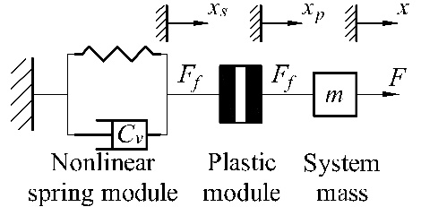**

**Figure 2.** Schematic representation of Hsieh’s friction model.

Depending on the direction of motion, the nonlinear spring module is defined as:20

(4)

where *k1s* and *k2s* are stiffness coefficients, *β* is a positive scalar, while *σr* and *xr* are, respectively, the force and the displacement at the reversal of the inner hysteresis loop (see points 2 and 3 in Figure 1b). The parameters *k1s*, *k2s* and *β* are estimated from the experimentally obtained *Ff* vs. *x* curve as shown in Figure 3.

C:\Users\Ervin\Desktop\Dokumenti_Backup\Doktorat\Doktorat Kamenar\Figures\Fig_Hsieh_identification\Fig5b-Model.EPS

**Figure 3.** Determination of the nonlinear spring parameters of Hsieh’s model.

On the other hand, the plastic behavior with its work hardening *xh* is described as:20

(5)

(6)

where *a* and *ψ* are positive constants related to work hardening, while *ρ* is a positive constant related to creep. The parameters *ρ* and *ψ* are estimated from experimental data assuming that the nonlinear spring has not undergone any deflection prior to the experiment, whereas *a* is found via a trial and error procedure.7, 20

## *GMS model*

The GMS friction model is based on *N* massless Maxwell-slip blocks connected in parallel that have all the same input – velocity *v*, and one output – friction force *Fi* acting on the *i*-th block (Figure 4a). Two states of either hysteresis with non-local memory in pre-sliding (where *v* is the derivative of the already defined state variable *z*) and slip with frictional lag, determine hence the behavior of each block. The latter depends on the stiffness *ki* of each block and the force limit *Wi* when the block starts slipping. Sliding dynamics of each block can, in turn, be represented by the Coulomb slip law; if more accurate modeling is needed, this can be replaced by the well-known Stribeck effect, i.e., via the so-called velocity weakening effect *s*(*v*) bounded on the lower end by Coulomb friction. The parameters of the model can thus be determined by a piecewise approximation of the experimentally obtained friction force *Ff* vs. displacement *x* data. This is expressed mathematically as:6-7, 23-24

(7)

$K_{i}=\frac{∆F_{i}}{∆D_{i}}=\frac{F_{i+1}-F_{i}}{D_{i+1}-D_{i}}$ (8)

Here *Ki* is the comprehensive stiffness contribution of all the Maxwell-slip blocks that are still in the pre-sliding state in a determined region of the overall pre-sliding motion regime (Figure 4b), while the stiffness of the last slip block is defined as $k_{N}=K_{N}$. The relative weight of each Maxwell-slip block can therefore be expressed as:6-7, 23-24

(9)

where *Di* is the maximum deflection of the *i*-th Maxwell-slip block before it starts slipping. Taking into consideration that the whole considered system will start sliding when the actuating force reaches the value of the breakaway (static friction) force *Fs*, equations (7-9) imply also that the sum of the frictional contributions *αi* adds up to 1.

The state of each block is hence determined based on the following conditions:6-7, 23-24

* if |*Fi*(*v*)| < |*Wi*(*v*)| the *i*-th block sticks:

$\frac{dF_{i}}{dt}=k_{i}∙v$ (10)

* otherwise the *i*-th block slips:

$\frac{dF_{i}}{dt}=sgn\left(v\right)∙C∙\left(α_{i}-\frac{F_{i}}{s\left(v\right)}\right)$ (11)

Here the constant positive number *C* is the attraction parameter associated to frictional lag that is relevant in the characterization of the transition from pre-sliding to sliding motion.6 In a previous work it was shown that a change of *C* in a large range of values has no major impact on system’s response.7 This finding is substantiated by the fact that in nanometric positioning precision and accuracy are far more important than positioning velocity and acceleration, i.e., that generally there are no sudden dynamic and/or periodic effects that would induce frictional lag.6, 23

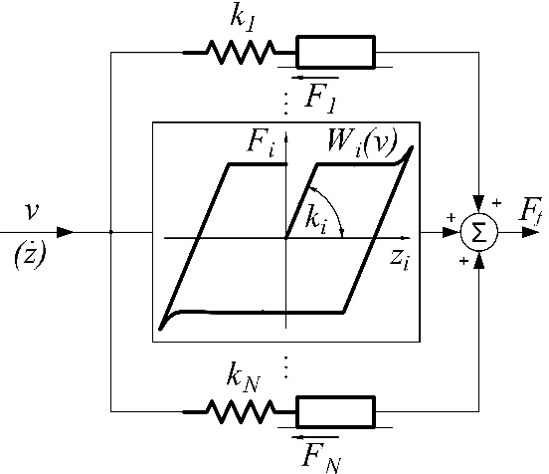 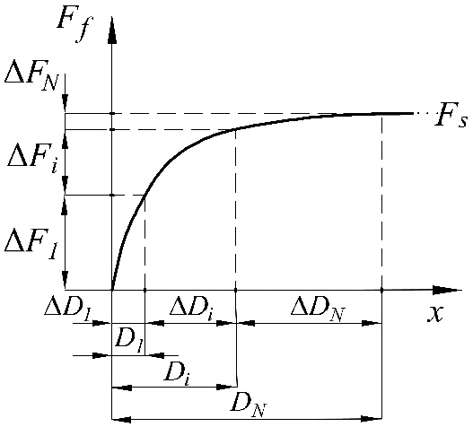

(a) (b)

**Figure 4.** GMS pre-sliding model: scheme (a) and approximation of the experimental *Ff* vs. *x* curve.

The total pre-sliding friction force *Ff* in the GMS model can thus finally be calculated as the sum of the contributions of the frictional forces of all the Maxwell-slip blocks:6-7, 23-24

(12)

Due to its comprehensiveness and simplicity, in literature it is found that the GMS model is often appropriate for real-time control purposes.7, 23-24

The provided report on the main features of Dahl’s, the LuGre, Hsieh’s and the GMS models allows identifying next their characteristic parameters on an elaborated experimental set-up devised for this purpose, and hence to compare the thus obtained measured responses to the simulated ones attained by implementing these models in MATLAB/Simulink.

# Experimental set-up

An experimental set-up, whose main foreseen application is the handling and assembly of microparts, is used in this work. It comprises three translational (*xa, ya, za*) and one rotational (*ca*) axis; in this work the characterization of the frictional phenomena is thoroughly analyzed on the *xa* translational axis with a 30 N movable weight (Figure 5). As detailed in Table 1, this axis is driven via a DC actuator-gearhead assembly connected via a coupling to a ball-screw supported on ball bearings. The rotation of the actuator is transferred into the translation of a stage guided on linear guideways. The feedback is, in turn, attained by using an incremental encoder coupled with an interpolation unit, while the control system is based on a National Instruments architecture available at our premises, i.e. the Field-Programmable Gate Array (FPGA) hardware and the LabVIEW software. Environmental disturbances are minimized by mounting the system on an anti-vibration optical bench. The thus obtained mechatronics system is characterized by multiple frictional sources and motion regimes but, as stated, due to the reduction rations of the gearhead and the ball-screw, its nanometric positioning will certainly happen when the sliding parts of the device are in pre-sliding.7 The pre-sliding frictional behavior of the linear guideways is thus thoroughly characterized next by identifying experimentally off-line the respective friction parameters.



**Figure 5.** Considered ultra-high precision positioning system.

The pre-sliding behavior is hence characterized in quasi-static conditions by slowly ramping the loading of the stage by applying to it a tangential force generated by a micro-tensile machine with a load resolution of 10 mN and, to observe the loops induced at motion reversal, subsequently reducing the magnitude of this force. Considering that nanometric displacements can be observed even after extended periods of time, the load is increased when the system comes to an almost complete rest,7 and transmitted to the stage via a carbon-based fiber. What is more, to avoid kinematic influences on the observed frictional phenomena, the rate of the stepwise application of the load is slow. As visible in Figure 5, the resulting displacements of the stage are measured via a Michelson-type laser Doppler interferometric system. To capture the variability of pre-sliding friction, more than 50 experiments are hence performed.7

**Table 1.** Main components of the experimental system.

|  |  |  |  |  |  |  |
| --- | --- | --- | --- | --- | --- | --- |
| Actuator | Coupling | Ball screw and bearings | Guideways | Feedback sensor | | Control system |
| Encoder | Interp. unit |
| Faulhaber M 1724 006 SR DC motor w/ Faulhaber 15A *i* = 19.2:1 gearhead | Misumi MCGS13-3-3 | SKF SH6x2R supported on 2 SKF 618/4 ball bearings | Schneeberger Minirail MN7 | Heidenhain MT 60k linear incr. encoder (10 μm period) | Heidenhain EXE 102 (100-fold interp.) | NI PXI-1050 w/ PXI-8196 controller, PXI 6221 DAQ and PXI-7833R FPGA module |
| 25 nm resolution | |

The typical nonlinear elasto-plastic pre-sliding frictional behavior with non-local memory is thus experimentally confirmed (typical data are shown in Figures 6 and 7). What is more, when performing motion reversal, i.e., when the tangential forces are reduced and increased again, it is established that the elastic component of the overall pre-sliding behavior is rather small, while the slope (i.e. stiffness) of the elastic component is almost constant irrespective of the position on the pre-sliding curve where the inner loop is initiated. The considered high-precision positioning device is hence characterized by breakaway forces of up to ~ 0.9 N and displacements in the range of up to 30-40 μm, which confirms once more that ultra-high precision positioning will certainly happen in the pre-sliding motion regime of the stage.

Based on the characteristic features of the considered pre-sliding friction models and the respective procedures of identifying their main parameters outlined above, the experiments allow obtaining the parameters of Dahl’s, the LuGre and Hsieh’s friction models as reported in Table 2. On the other hand, the experimentally determined parameters of the GMS model, where in a first instance six Maxwell-slip blocks are considered (see below), are reported in Table 3.

**Table 2.** Experimentally determined parameters of Dahl’s, the LuGre and Hsieh’s models.

|  |  |  |  |  |  |
| --- | --- | --- | --- | --- | --- |
| Dahl | | LuGre | | Hsieh | |
| *σ0*, N/m | 320000 | *σ0*, N/m | 195000 | *k1**s*, N/m | 51540 |
| *FC*, N | 0.9 | *σp*, N/m | 4416 | *k2s*, N/m | 2026400 |
| *n*, - | 1.6 | *FC*, N | 0.9 | *Cv*, - | 5000 |
|  |  | *Fs*, N | 0.9 | *β*, - | 3216500 |
|  |  |  |  | *ρ*, - | 500 |
|  |  |  |  | *ψ*, - | 31200 |
|  |  |  |  | *a, -* | 3.22 |

The behavior of the considered nanometric positioning system obtained via these pre-sliding friction models, implemented as MATLAB/Simulink routines complemented with the experimentally determined characteristic values, can therefore be finally simulated and compared to the experimental data on the pre-sliding behavior of the considered ultra-high precision positioning device (Figure 6). It can thus be seen that, as supposed, neither Dahl’s nor the LuGre model allow capturing the non-local memory effects. On the other hand, the pre-sliding behavior attained by using Hsieh’s and the GMS models match excellently experimental data, especially considering that the in repetitive measurements the data is characterized by a dispersion of up to ± 15 % (not shown in Figure 6 for clarity reasons). What is more, although Hsieh’s model gives results closely matching the experimental ones, the determination of the numerous parameters of Hsieh’s model proves to be cumbersome while they are physically hard to interpret. In fact, instead of estimating all parameters together as in the case of the GMS model,6-7 the motion corresponding to the characteristics of each of the modules of Hsieh’s model must be isolated and the associated parameters are estimated separately. As shown in recent literature, the formulation of Hsieh’s model itself is, moreover, challenging to incorporate into real-time control systems.7, 25 On the other hand, the GMS pre-sliding friction model not only provides results closely approximating the experimental ones, but it is relatively simple to implement.7 What is more, while Hsieh’s model can be used to model pre-sliding friction only, when the motion of the considered positioning device extends also to the sliding regime, the GMS model can be used to simulate the overall behavior in both motion regimes with a smooth transition between the description of the respective frictional disturbances.7

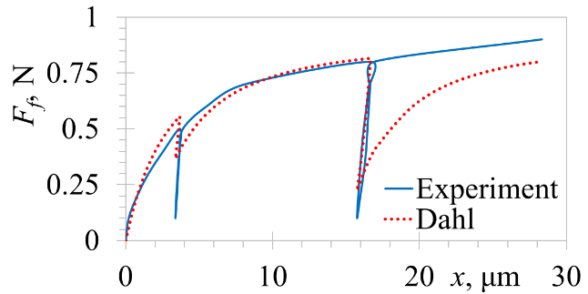 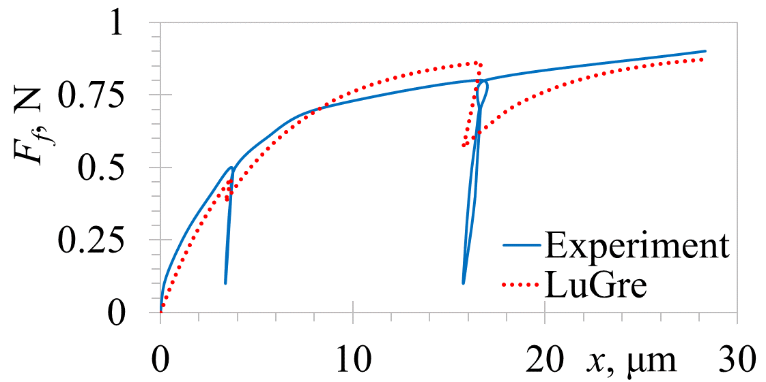

(a) (b)

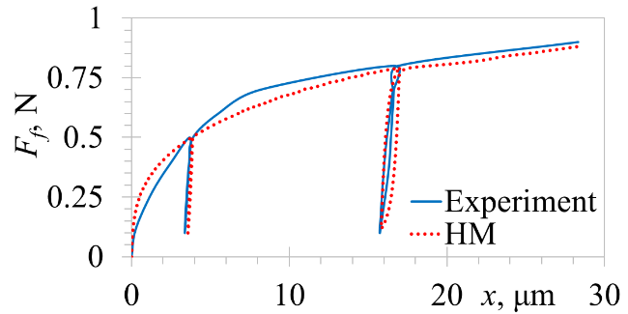 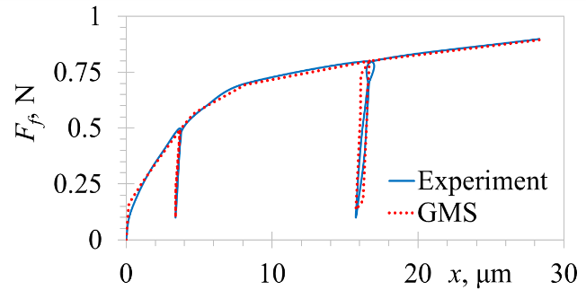

(c) (d)

**Figure 6.** Comparison of the experimental and modeled responses for different friction models: Dahl’s (a), the LuGre (b), Hsieh’s (c) and the GMS (d) model.

Taking into account all these considerations, the GMS friction model is thoroughly analyzed in the next section with the aim of determining the minimal number of Maxwell-slip blocks needed to efficiently simulate the factual pre-sliding behavior of the ultra-high precision positioning device, while allowing its simple implementation in real-time control systems.

# Validation of the GMS pre-sliding friction model

Although in literature it is suggested that four Maxwell-slip elements could be sufficient to provide a good correspondence of the modelled behavior with experimental pre-sliding data, a validation of this statement is generally not provided.6 What is more, even though in some prior art it is affirmed that a higher number of Maxwell-slip blocks does not significantly improve the results,whereas it bears an additional computational burden,24 a structured and methodologically rigorous analysis of how the number of the slip blocks in the GMS model affects the accuracy of the obtained results was not provided. To complement thus the current state-of-the-art a detailed analysis of this issue is performed next. The frictional force vs. displacement pre-sliding data obtained experimentally (see above), is thus used to calculate the parameters of the Maxwell-slip blocks as previously explained. The respective characteristic parameters calculated for a varying number of Maxwell-slip blocks are reported in Table 3. By using this data, the model implemented in MATLAB is used to simulate the GMS-related responses. The results of the comparison of the hence obtained pre-sliding GMS behavior, as function of the number of the slip blocks, to the average experimental data, are depicted in Figure 7 where once more the large variability of experimental data in repetitive measurements is confirmed.

C:\Users\Saša\AppData\Local\Microsoft\Windows\INetCache\Content.Word\Fig7_1.tiff C:\Users\Saša\AppData\Local\Microsoft\Windows\INetCache\Content.Word\Fig7_2.tiff

**Figure 7.** GMS responses for a varying number of Maxwell-slip blocks compared to experimental data: 2, 3 and 4 blocks (a) and 6 and 10 blocks (b).

From the data shown in Figure 7a it can be inferred that indeed at least four Maxwell-slip blocks do approximate well the measurements although a larger number of blocks (cf. Figure 7b) allows an even better matching of the experimental data with the modelled response. In fact, a sufficient number of blocks is needed especially to capture well the large and highly variable slope of the pre-sliding behavior for small actuating forces. Since, however, a larger number of blocks implies a marked increase of the computational complexity,24 and thus an increased difficulty in implementing the GMS model in real-time control systems, an particularized quantification of the number of required blocks is needed.

**Table 3.** Parameters of the GMS pre-sliding model vs. number of considered slip blocks.

|  |  |  |  |  |  |  |  |  |  |  |  |
| --- | --- | --- | --- | --- | --- | --- | --- | --- | --- | --- | --- |
| # of blocks |  | *i-*th block’s *k* (N/m) and *α* | | | | | | | | | |
| 1 | 2 | 3 | 4 | 5 | 6 | 7 | 8 | 9 | 10 |
| 2 | *ki* | 113948 | 8870 |  |  |  |  |  |  |  |  |
| *αi* | 0.616 | 0.384 |  |  |  |  |  |  |  |  |
| 3 | *ki* | 325379 | 40535 | 7886 |  |  |  |  |  |  |  |
| *αi* | 0.352 | 0.307 | 0.341 |  |  |  |  |  |  |  |
| 4 | *ki* | 313728 | 43670 | 10545 | 5858 |  |  |  |  |  |  |
| *αi* | 0.339 | 0.236 | 0.171 | 0.253 |  |  |  |  |  |  |
| 5 | *ki* | 270313 | 57886 | 29198 | 10545 | 5858 |  |  |  |  |  |
| *αi* | 0.292 | 0.125 | 0.158 | 0.171 | 0.253 |  |  |  |  |  |
| 6 | *ki* | 270313 | 57886 | 29198 | 9503 | 2604 | 4295 |  |  |  |  |
| *αi* | 0.292 | 0.125 | 0.158 | 0.154 | 0.084 | 0.186 |  |  |  |  |
| 7 | *ki* | 270313 | 57886 | 24903 | 10349 | 4295 | 1759 | 4295 |  |  |  |
| *αi* | 0.292 | 0.125 | 0.135 | 0.112 | 0.093 | 0.057 | 0.186 |  |  |  |
| 8 | *ki* | 270313 | 57886 | 24903 | 8590 | 3517 | 1927 | 1985 | 4678 |  |  |
| *αi* | 0.292 | 0.125 | 0.135 | 0.093 | 0.057 | 0.042 | 0.054 | 0.202 |  |  |
| 9 | *ki* | 270313 | 57886 | 24903 | 8590 | 3517 | 1927 | 1219 | 1149 | 4295 |  |
| *αi* | 0.292 | 0.125 | 0.135 | 0.093 | 0.057 | 0.042 | 0.033 | 0.037 | 0.186 |  |
| 10 | *ki* | 270313 | 57886 | 24903 | 8590 | 3517 | 1927 | 1219 | 841 | 616 | 3987 |
| *αi* | 0.292 | 0.125 | 0.135 | 0.093 | 0.057 | 0.042 | 0.033 | 0.027 | 0.023 | 0.173 |

To objectively quantify how well the modelled response for the considered number of Maxwell-slip blocks fits the experimentally determined pre-sliding behavior of the ultra-high precision positioning system, the normalized Mean Square Error (*MSE*) statistics indicator is hence chosen:9

(13)

where ${σ_{F_{f}}}^{2}$ is the measured force variance (deviation of the measurements with respect to their mean value), *Ff* is the vector of the measured frictional forces and $\hat{F_{f}}$ is the vector of frictional forces estimated by using the GMS model on *Ns* samples, while *is* represents the sample index. The constant 100 serves just to obtain percent values of the relative discrepancy of the modelled with respect to the mean experimental values.

The thus obtained normalized *MSE* percentage values versus the number of the considered Maxwell-slip blocks *N* are shown in Figure 8. The data shown in Figures 7 and 8 allow establishing clearly that the results attained by using the GMS friction model with two Maxwell-slip blocks are unsatisfactory; two slip blocks can therefore be reputed insufficient to model and compensate the effective frictional disturbances and hence also inappropriate to validate the efficiency of other friction model, as incautiously done in recent literature.12 Already when three Maxwell-slip blocks are used, the obtained GMS results fall within the dispersion of the experimental pre-sliding data. In fact, while the stochastic component of the measurements is up to 15 %, the normalized MSE value, i.e., the error between the modelled and the factual data, is ~ 14 %. When, as often suggested in literature,6, 24 four GMS slip blocks are used, the MSE is still ~ 3 %. In the case when six Maxwell-slip blocks are used, as was done in the validation of the GMS friction model in Figure 6, the normalized MSE is below 1 %, i.e., the model approximates excellently the behavior of the considered mechatronics device while still allowing a relatively straight-forward implementation in real-time control systems. On the other hand, using more than six Maxwell-slip blocks does not improve significantly the quality of the obtained results (while for 6 blocks the MSE is 0,7 %, for 7 blocks it decreases only to 0,3 %), while unnecessarily complicating the determination of the characteristic parameters and the implementation of the GMS model in real-time control systems.

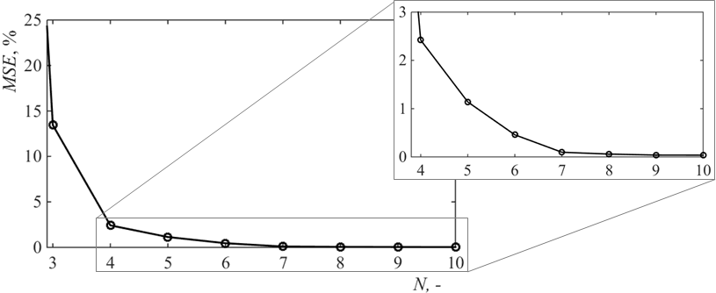

**Figure 8.** Dependence of the normalized MSE on the number of considered Maxwell-slip blocks.

# Conclusions and outlook

Different friction models are validated in this work by identifying their characteristic parameters and comparing the resulting simulated pre-sliding behavior with factual experimental data attained on a nanometric positioning device. It is hence established that only Hsieh’s and the GMS model allow efficiently predicting all the relevant frictional phenomena characteristic for the pre-sliding motion regime where ultra-high precision positioning certainly happens. However, Hsieh’s model is qualitative and it comprises a large number of characteristic parameters with different physical foundation that are hard to identify. What is more, its implementation in real-time control systems, especially if based on disturbance observers, can be difficult due to the large resulting computational load.25 Also, while the GMS friction model can be easily extended to incorporate the sliding behavior without the need for a switching function between this and the pre-sliding motion regime, Hsieh’s model is able to deal with pre-sliding friction only.

The structured sensitivity analysis of the relative errors depending on the number of characteristic blocks of the GMS friction model is thus methodologically conducted in this work allowing to establish that three blocks are the minimum needed to approximate the behavior of the factual precision positioning systems, while six blocks allow representing excellently the real behavior, while not influencing significantly the possibility of implementing the GMS model in real-time control systems. The rigorous approach adopted in this work creates thus the preconditions for the development of adaptive control algorithms aimed at an efficient real-time compensation of the stochastic variability of pre-sliding frictional disturbances. In future work, refined control typologies, coupled with identification procedures and metrics suitable to discriminate on-line the influence of the different frictional parameters, will thus be considered. In this frame, a Koopman-based model predictive control (MPC) will be applied since this approach allows “lifting” the nonlinear dynamics of the considered device into a higher dimensional space where its behavior can be predicted by a linear system; the computational complexity of the thus obtained controller should thus be comparable to that of MPCs for linear dynamic systems of the same size.26 The resulting positioning performances will be evaluated numerically and compared to the actual experimental response of the herein considered ultra-high precision mechatronics device.

# Acknowledgements

This work was made possible by using equipment funded via the EU ERDF project no. RC.2.2.06-0001: “Research Infrastructure for Campus-based Laboratories at the University of Rijeka (RISK)”.

# Declaration of conflicting interests

The authors declare no potential conflicts of interest with respect to the research, authorship and/or publication of this article.

# References

1. Schmidt RM, Schitter G, Rankers A et al. *The design of high performance mechatronics – high-tech functionality by multidisciplinary system integration*. 2nd ed. Delft, NL: Delft University Press, 2014.

2. Bhushan B. ed. *Springer handbook of nanotechnology*. 3rd ed. Berlin, DE: Springer, 2010.

3. Slocum AH. Precision machine design. Dearborn, MI, USA: Society of Manufacturing Engineers, 1992.

4. Zelenika S and Kamenar E. *Precizne konstrukcije i tehnologija mikro- i nanosustava I – Precizne konstrukcije*. Rijeka, HR: Uni Rijeka – Faculty Eng, 2015.

5. Armstrong-Helouvry B, Dupont P and Canudas de Wit C. A Survey of models, analysis tools and compensation methods for the control of machines with friction. *Automatica* 1994; 30(7): 1083-1138.

6. Al-Bender F, Lampaert V and Swevers J. The generalized Maxwell-slip model: A novel model for friction simulation and compensation. *IEEE T Automat Contr* 2005; 50(11): 1883–1887.

7. Kamenar E and Zelenika S. Nanometric positioning accuracy in the presence of presliding and sliding friction: modelling, identification and compensation. *Mech Based Des Struc* 2017;45(1): 111-126.

8. Marques F, Flores P, Pimenta Claro JC et al. A survey and comparison of several friction force models for dynamic analysis of multibody mechanical systems. *Nonlinear Dynam* 2016;86(3): 1407-1443.

9. Worden K, Wong CX, Parlitz U, et al. Identification of pre-sliding and sliding friction dynamics: Grey box and black-box models. *Mech Syst Signal Pr* 2007; 21(1): 514-534.

10. Courtney-Pratt J and Eisner E. The effect of a tangential force on the contact of metallic bodies. *P Roy Soc A-Math Phy* 1957; 238(1215): 529–550.

11. Al-Bender F and De Moerlooze K. Characterization and modeling of friction and wear: an overview. *Sust Constr & Des* 2011; 2(1): 19-28.

12. Ruderman M and Bertram T. Two-state dynamic friction model with elasto-plasticity. *Mech Syst Signal Pr* 2013; 39(1-2): 316-322.

13. Swevers J, Al-Bender F, Ganseman CG, et al. An integrated friction model structure with improved presliding behavior for accurate friction compensation. *IEEE T Automat Contr* 2000; 45(4): 675–686.

14. Piatkowski T. Dahl and LuGre dynamic friction models — The analysis of selected properties. *Mech Mach Theory* 2014; 73: 91-100.

15. Ismail M, Ikhouane F and Rodellar J. The Hysteresis Bouc-Wen Model, a Survey. *Arch Comput Methods Eng* 2009; 16: 161-188.

16. Dahl PR. A solid friction model. Technical report Contract No. AF04695-67-C-0158, Los Angeles, CA: Aerospace Corp, 1968.

17. Canudas de Wit C, Olsson H, Astrom KJ et al. A new model for control of systems with friction. *IEEE T Automat Contr* 1995; 40(3): 419-425.

18. Canudas de Wit C. Comments on "A new model for control of systems with friction". *IEEE T Automat Contr* 1998;43(8): 1189-1190.

19. Dupont P, Hayward V, Armstrong B et al. Single state elasto-plastic friction models. *IEEE T Automat Contr* 2002; 47(5): 787-792.

20. Hsieh C, Pan YC. Dynamic behavior and modelling of the pre-sliding static friction. *Wear* 2000; 242(1–2): 1–17.

21. Do TN, Tjahjowidodo T, Lau MWS et al. An investigation of friction-based tendon sheath model appropriate for control purposes. *Mech Syst Signal Pr* 2014; 42(1-2): 97-114.

22. Liu YF, Li J, Zhang ZM et al. Experimental comparison of ﬁve friction models on the same test-bed of the micro stick-slip motion system. *Mech Sci* 2015; 6: 15-28.

23. Lampaert V, Al-Bender F and Swevers J. A generalized Maxwell-slip friction model appropriate for control purposes. In *Proc Physics and Control Int Conf* 2003, Saint Petersburg, RU, pp. 1170-1177.

24. Tjahjowidodo T, Al-Bender F and Van Brussel H. Friction identification and compensation in a DC motor. In *Proc. 16th IFAC World Cong* 2005, Prague, CZ.

25. Chih-Jer L, Her-Terng Y and Yun-Cheng T. Identification and compensation of Nonlinear Friction Characteristics and Precision Control for a Linear Motor Stage. *IEEE/ASME T Mechatronics* 2013; 18(4): 1385-1396.

26. Korda M and Mezic I. Linear predictors for nonlinear dynamical systems: Koopman operator meets model predictive control. *arXiv preprint arXiv:1611.03537* 2016/2017.

# Figure captions

**Figure 1.** Pre-sliding behavior: motion profile (a) and corresponding frictional response (b).

**Figure 2.** Schematic representation of Hsieh’s friction model.

**Figure 3.** Determination of the nonlinear spring parameters of Hsieh’s model.

**Figure 4.** GMS pre-sliding model: scheme (a) and approximation of the experimental *Ff* vs. *x* curve.

**Figure 5.** Considered ultra-high precision positioning system.

**Figure 6.** Comparison of the experimental and modeled responses for different friction models: Dahl’s (a), the LuGre (b), Hsieh’s (c) and the GMS (d) model.

**Figure 7.** GMS responses for a varying number of Maxwell-slip blocks compared to experimental data: 2, 3 and 4 blocks (a) and 6 and 10 blocks (b).

**Figure 8.** Dependence of the normalized MSE on the number of considered Maxwell-slip blocks.

# Table captions

**Table 1.** Main components of the experimental system.

**Table 2.** Experimentally determined parameters of Dahl’s, the LuGre and Hsieh’s models.

**Table 3.** Parameters of the GMS pre-sliding model vs. number of considered slip blocks.

1. **Corresponding author:**

   Saša Zelenika, University of Rijeka – Faculty of Engineering, Vukovarska 58, 51000 Rijeka, Croatia &   
   Centre for Micro- and Nanosciences and Technologies, Radmile Matejčić 2, 51000 Rijeka, Croatia.  
   E-mail: [sasa.zelenika@riteh.hr](mailto:sasa.zelenika@riteh.hr) [↑](#footnote-ref-1)