# **REliaBility and Uncertainty of Ship decision support system for safe and greener navigation (REBUS)**

Funded by: Croatian Science Foundation - HRZZ-IP-2022-10-2821

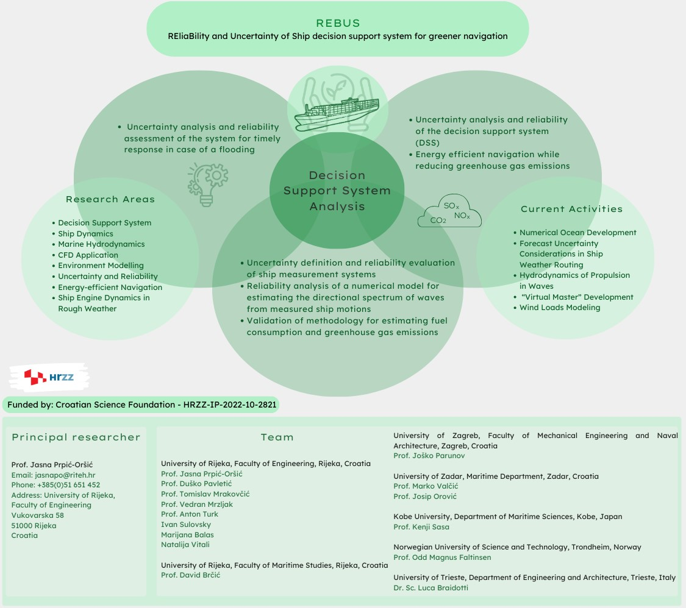

**Project summary**

The goal of the research in a frame of project REliaBility and Uncertainty of Ship decision support system for greener navigation – REBUS is the analysis of reliability and uncertainties related to Decision Support System (DSS) is planned for ship captains as well as machine commanders, which would contribute to ''greener'' and safer navigation of ships.

The project continues the ongoing Croatian Science Foundation project, No. IP-2018-01-3739 DEcision Support System for green and safe ship RouTing (DESSERT), which is developing a decision support system that takes into account not only economic (consumption) but also environmental and safety aspects of navigation.

Research related to DSS analysis will proceed in two basic directions: Uncertainty analysis and reliability assessment of the decision support system for more energy efficient navigation while reducing greenhouse gas emissions; Uncertainty analysis and reliability assessment of the system for timely response in case of a flooding.

Measurements of navigation and operational parameters of the ship using various measurement systems will be analyzed from the point of view of defining uncertainty and evaluating the reliability of the measurements themselves. A large database of measured data from a bulk carrier will be used to analyze the reliability of a numerical model for estimating the directional spectrum of waves from measured ship motions and to validate the methodology for estimating fuel consumption and greenhouse gas emissions.

The goal is to systematically analyze the shipboard decision support system, taking into account design, engineering, and maritime expertise, to create a safer and more environmentally efficient or "greener" ship and navigation. The project team consists of scientists who are experts in naval architecture, mechanical engineering, marine engineering and computer science, which enables a multidisciplinary solution to this problem.

**Principal researcher:**

Prof. Jasna Prpić-Oršić

Email: [jasnapo@riteh.hr](mailto:jasnapo@riteh.hr)

Phone: +385(0)51 651 452

Address: University of Rijeka, Faculty of Engineering

Vukovarska 58

51000 Rijeka

Croatia

**Team**

**University of Rijeka, Faculty of Engineering, Rijeka, Croatia**

Prof. Jasna Prpić-Oršić

Prof. Duško Pavletić

Prof. Tomislav Mrakovčić

Prof. Vedran Mrzljak

Prof. Anton Turk

Ivan Sulovsky

Marijana Balas

Natalija Vitali

**University of Rijeka, Faculty of Maritime Studies, Rijeka, Croatia**

Prof. David Brčić

**University of Zagreb, Faculty of Mechanical Engineering and Naval Architecture, Zagreb, Croatia**

Prof. Joško Parunov

**University of Zadar, Maritime Department, Zadar, Croatia**

Prof. Marko Valčić

Prof. Josip Orović

**Kobe University, Department of Maritime Sciences, Kobe, Japan**

Prof. Kenji Sasa

**Norwegian University of Science and Technology, Trondheim, Norway**

Prof. Odd Magnus Faltinsen

**University of Trieste, Department of Engineering and Architecture, Trieste, Italy**

Dr. Sc. Luca Braidotti

**Research Areas**

Decision Support System

Ship Dynamics

Marine Hydrodynamics

CFD Application

Environment Modelling

Uncertainty and Reliability

Energy-efficient Navigation

Ship Engine Dynamics in Rough Weather

**Current Activities**

Numerical Ocean Development

Forecast Uncertainty Considerations in Ship Weather Routing

Hydrodynamics of Propulsion in Waves

“Virtual Master” Development

Wind Loads Modeling

**Recent Publications (2024)**

Jasna Prpić-Oršić, Odd Magnus Faltinsen, Marko Valčić, Ivan Sulovsky: Uncertainties of the decision support system for green ships, Journal of Croatian Science Academy - Glasnik HAZU - Časopis hrvatske akademije znanosti i umjetnosti, 2024, HAZU, Zagreb (invited paper, accepted for publication)

I. Sulovsky, J. Prpić-Oršić: On the development of numerical ocean for seakeeping simulations in Journal of Maritime and Transportation Sciences, 2024. (under review process)

M. Balas, R. Dejhala, J. Prpić-Oršić: Hydrodynamic aspects of a ship in weather routing within the context of slow steaming, Journal of Maritime and Transportation Sciences, 2024. (under review process)

M. Balas, J. Prpić-Oršić, M. Valčić: Forecast uncertainty considerations in ship weather routing, Proceedings of Maritime Technology and Engineering - MARTECH 2024, Lisbon 14.-16.5. 2024. (under review process)

I. Sulovsky, J. Prpić-Oršić: Hydrodynamics of ship propulsion in waves: A review, Proceedings of Maritime Technology and Engineering - MARTECH 2024, Lisbon 14.-16.5. 2024. (under review process)

**Plenary sessions**

J. Prpić-Oršić, I. Sulovsky, M. Balas: REliaBility and Uncertainty of Ship decision support system for safe and greener navigation (REBUS), School of Naval Architecture and Ocean Engineering (SNAOE) of Indian Maritime University, Ship Life-Cycle Modelling and Simulation Challenges - International Expert Lecture Series 6.2.2024.

